Autonomous University Robot Assistant
Michael Fritzer, Muhammed Faseeh,
David Haybarger, Kevin Lee

Functional System Requirements

REVISION – 1
30 September 2025
Functional System Requirements
for the
Autonomous University Robot Assistant

Prepared by:

Muhammed Faseeh 10/03/2025
_____________________________
Author Date

Approved by:

Michael Fritzer 10/03/2025
_____________________________
Project Leader Date

Byung-Jun Yoon XX/XX/2025
_____________________________
Professor Date

Fahrettin Ay XX/XX/2025
_____________________________
T/A Date

Change Record
Rev. | Date | Originator | Approvals | Description
1 | 09/30/2025 | Michael Fritzer,  Muhammed Faseeh,  David Haybarger,  Kevin Lee | Michael Fritzer,Fahrettin Ay,Byung-Jun Yoon | Draft Release

Table of Contents
Table of Contents III
List of Tables IV
No table of figures entries found. IV
List of Figures V
1. Introduction 6
1.1. Purpose and Scope 6
1.2. Responsibility and Change Authority 7
2. Applicable and Reference Documents 8
2.1. Applicable Documents 8
2.2. Reference Documents 9
2.3. Order of Precedence 9
3. Requirements 10
3.1. System Definition 10
3.2. Characteristics 12
3.2.1. Functional / Performance Requirements 12
3.2.2. Physical Characteristics 12
3.2.3. Electrical Characteristics 13
3.2.5. Failure Propagation 14
4. Support Requirements 15
Appendix A Acronyms and Abbreviations 16

List of Tables
Table 1. Subsystem Leads 7
Table 2. Applicable Documents 8
Table 3. Reference Documents 9
List of Figures
Figure 1. Project Conceptual Image 7
Figure 2. Block Diagram of System 10

Introduction

Purpose and Scope
Engineering students often face challenges in laboratory environments where access to direct instructor assistance is limited. Rather than relying solely on professors or teaching assistants to provide individualized help, our aim is to create an autonomous system that supports students during lab activities. The Autonomous University Robot Assistant (ARUA) will serve as an interactive teaching aid by combining natural language processing (NLP) with robotic functionality to answer questions, assist with circuit troubleshooting, and provide guided instruction.
With our system, data from physical circuits can be gathered through integrated sensors and probing mechanisms, then analyzed by the AI model to deliver actionable feedback. The robotic platform will support movement, interaction, and integrated measurement tools, while the AI core will handle interpretation and explanation of engineering concepts. To enhance the accuracy and reliability of responses in relation to the laboratory manuals & papers being utilized, the system will employ retrieval augmented generation (RAG), allowing it to reference a curated database of university created lab manuals, course documents, and technical papers. This ensures that student queries are not only answered conversationally but also grounded in official instructional and reference material.
Our system will reduce reliance on constant instructor availability, improve learning outcomes in lab settings, and provide scalable support for future academic environments.
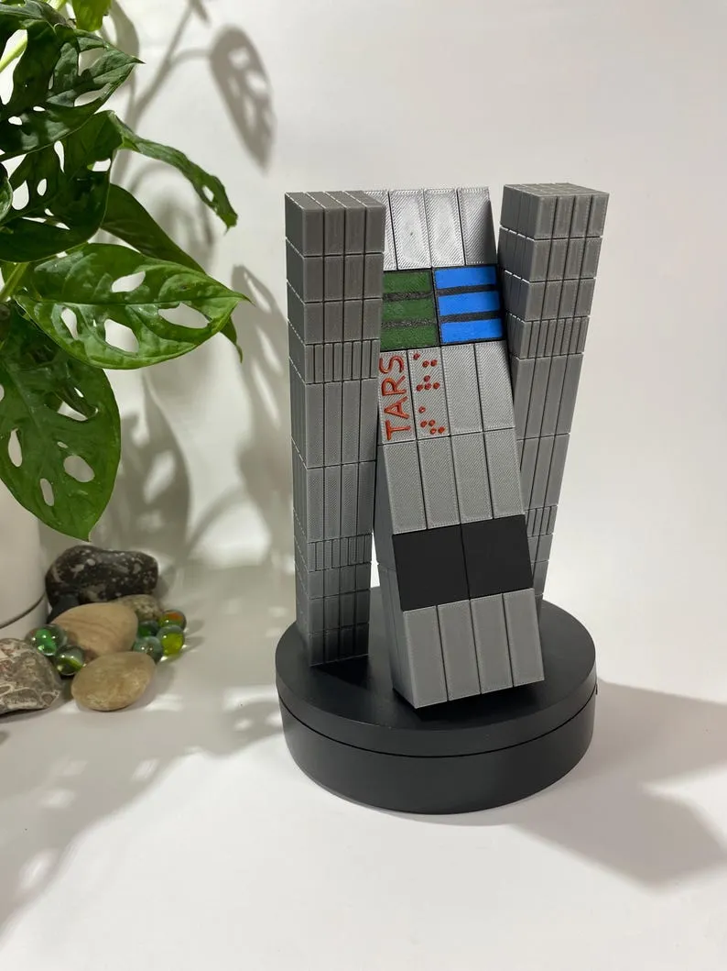
Figure 1. Project Conceptual Image

Responsibility and Change Authority
The team leader, Michael Fritzer, will be responsible for verifying all requirements of the project are met. These requirements can only be changed with the approval of the team leader and Professor Byung-Jun Yoon.

Subsystem | Responsibility
Artificial Intelligence | Michael Fritzer
Hardware | Muhammed Faseeh
Robotics | David Haybarger
Voice and Image Recognition | Kevin Lee
Table 1: Subsystem Leads

Applicable and Reference Documents

Applicable Documents
The following documents, of the exact issue and revision shown, form a part of this specification to the extent specified herein:

Document Number | Revision/Release Date | Document Title
DOD-HDBK-791 | 3/17/1998 | Maintainability Design Techniques Metric
MIL-HDBK-217 | Revision F – 2/28/1995 | Reliability Prediction of Electronic Equipment
MIL-HDBK-263 | Revision B – 7/31/1994 | Electrostatic Discharge Control Handbook for Protection of Electrical and Electronic Parts, Assemblies and Equipment
MIL-HDBK-338 | Revision B – 10/1/1998 | Electronic Reliability Design
IPC A-610E | Revision E – 4/1/2010 | Acceptability of Electronic Assemblies
MIL-DTL-38999 | Revision L – 5/10/2012 | General Specification for Connectors, Electrical, Circular, Miniature, High Density, Quick Disconnect (Bayonet, Threaded, and Breech Coupling), Environment Resistant, Removable Crimp and Hermetic Solder Contacts
MIL-STD-461 | Revision E – 8/20/1999 | Requirements for the Control of Electromagnetic Interface Characteristics of Subsystems and Equipment

Table 2: Applicable Documents

Reference Documents

The following documents are reference documents utilized in the development of this specification. These documents do not form a part of this specification and are not controlled by their reference herein.

Document Number | Revision/Release Date | Document Title
ESP32-TRM | 2020 | Espressif ESP32 Technical Reference Manual
MOLICEL-INR18650P26A-V2 | 2020 | Lithium-Ion Rechargeable Battery – INR18650P26A V2 Product Datasheet
IEEE Standard 802.11 | 2020 | (Wi-Fi) - Wireless LAN Communication
MCP23X17-DS | 2021 | Adafruit MCP23X17 Datasheet
LD-2015MG-DS | 2022 | Servo Motor LD-3015MG Datasheet
NVIDIA-JetsonNano-DS | 2022 | NVIDIA Jetson Nano Developer Kit Datasheet
arXiv:2410.05779 | 2024 | Retrieval-Augmented Generation for Large Language Models: A Survey
META-SAM2 | 2024 | Segment Anything Model 2 (SAM 2) — Meta AI
GITHUB-RAG-LOCAL-LLM | 2025 | Local LLM with RAG Implementation — A. Scotti
Bluepad32-LIB | 2025 | Bluepad32 Library Documentation
ALTIUM-PCB-TUT | 2025 | Altium Designer Tutorial – Creating and Configuring PCB Document

Table 3: Reference Documents

Order of Precedence
In the event of a conflict between the text of this specification and an applicable document cited herein, the text of this specification takes precedence without any exceptions.

All specifications, standards, exhibits, drawings or other documents that are invoked as “applicable” in this specification are incorporated as cited. All documents that are referred to within an applicable report are considered to be for guidance and information only, except ICDs that have their relevant documents considered to be incorporated as cited.

Requirements

System Definition
The AURA system is an autonomous, bench-top robotic assistant intended for use in university laboratory environments. It combines artificial intelligence (AI), computer vision, multimodal input/output (I/O), and embedded control to support students with laboratory tasks. The system shall provide guidance through natural language interaction, execute probing/measurement tasks, and deliver contextually accurate responses based on curated academic resources.
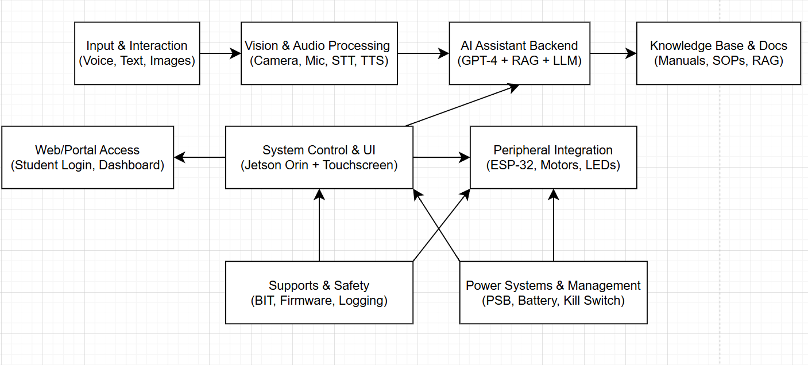
Figure 2. Block Diagram of System

At a high level, the system is composed of the following subsystems (see Figure 2):
- Input & Interaction
  - Accepts queries via voice, text, and images.
  - Acts as the primary interface for students initiating conversations or uploading lab files.
- Vision & Audio Processing
  - Handles speech-to-text (STT), text-to-speech (TTS), and image recognition using the camera and microphone array.
  - Supports resistor value identification, circuit recognition, and natural conversation flow.
- AI Assistant Backend
  - Core intelligence powered by a Local custom LLM with Retrieval Augmented Generation (RAG).
  - Uses curated documents (manuals, SOPs, course materials) to deliver context-aware answers.
- Knowledge Base & Documentation
  - Stores and manages reference material for lab guidance.
  - Interfaces with the AI backend to provide verifiable, source-driven responses.
- System Control & User Interface (UI)
  - Provides a touchscreen interface for direct interaction, file management, and system settings.
  - Acts as the central hub, coordinating between backend AI, peripherals, safety subsystems, and web/portal access.
- Peripheral Integration
  - Managed via ESP-32 microcontroller.
  - Supports motors, LEDs, and gesture/expressive outputs to enhance user engagement.
- Support & Safety
  - Includes firmware controls, logging, and Built-In Test (BIT) functionality.
  - Ensures system reliability through fault detection, isolation, and recovery.
- Power Systems & Management
  - Provides regulated PSU, battery support, and kill switch functionality.
  - Manages stable power delivery to Jetson Orin, peripherals, and safety circuits.
- Web/Portal Access
  - Extends accessibility through a student login dashboard.
  - Enables instructors and students to review logs, upload documents, and monitor usage remotely.

Characteristics

Functional / Performance Requirements

Query Response
The system shall process and respond to student queries via natural language within 3 seconds for text-based queries and 5 seconds for audio or image-based queries.

Rationale: Ensures minimal disruption to laboratory workflows and promotes real-time usability.

Knowledge Retrieval
The system shall employ Retrieval Augmented Generation (RAG) to reference at least 90% of queries against curated course documents, lab manuals, and SOPs.

Rationale: Provides authoritative, context-driven responses aligned with academic material.

Multimodal Input
The system shall support text, voice, and image input as interaction modalities.

Rationale: Increases accessibility and flexibility for diverse student needs.

Session Logging
The system shall log all interactions, including queries and AI responses, to a local database with timestamps.

Rationale: Enables instructors to review student interactions for grading, feedback, or troubleshooting.

Physical Characteristics

Mass
The mass of the Autonomous University Robot Assistant System shall be less than or equal to 7 kilograms.

Rationale: This is a requirement specified by the deployable environment of the system which should be easily placed and removed for a laboratory workbench.

Volume Envelope
The volume envelope of the Search and Rescue System shall be less than or equal to 36 inches in height, 8 inches in width, and 12 inches in length.

Rationale: This is a requirement specified by the deployable environment of the system which should be easily placed and removed for a laboratory workbench.

Electrical Characteristics

3.2.3.1. Inputs
- The presence or absence of any combination of the input signals in accordance with ICD specifications applied in any sequence shall not damage the Autonomous University Robot Assistant System (AURA), reduce its life expectancy, or cause any malfunction, either when the unit is powered or when it is not.

- No sequence of command shall damage the Autonomous University Robot Assistant System, reduce its life expectancy, or cause any malfunction.

Rationale: By design, this limits the chance of damage or malfunction due to user or technician error.

Power Consumption
The maximum peak power consumption of the system shall not exceed 65 watts under full operational load, including Jetson Orin Nano compute, ESP32 peripherals, motors, and sensor arrays.

Rationale: This is a requirement specified by the deployable environment of the system which should be easily placed and removed for a laboratory workbench.

Input Voltage Level
The system shall operate from a nominal 14.6 VDC battery supply (4-cell LiFePO₄ pack), with an acceptable input range of 12.0 VDC to 14.6 VDC.

For wall-powered operation, the system shall accept input from a regulated AC/DC power adapter providing 19–24 VDC, which is stepped down via an internal buck converter to the system’s required operating voltage.

Rationale: Supports rechargeable LiFePO₄ batteries commonly used for safe, long-cycle applications. Ensures compatibility with both portable battery use and continuous bench-top operation from a wall outlet. Provides stable voltage regulation for sensitive electronics (Jetson Orin Nano, ESP32, sensors, motors).

Input Noise and Ripple
The input noise and ripple for the Autonomous University Robot Assistant System shall operate while in the presence of a 1.5 Volt RMS ripple superimposed on the steady-state voltage over the frequency range of 0 Hz to AC.

External Commands
The Autonomous University Robot Assistant (AURA) system shall tolerate and operate correctly with the following input noise and ripple conditions at the power entry module (PEM):
- Battery Operation (13.6 V nominal LiFePO₄, 12.0–14.6 V range):
  - Ripple/noise shall not exceed ≤50 mVpp in the frequency range of 0 Hz to 20 kHz.
  - Ripple/noise shall not exceed ≤100 mVpp in the frequency range of 20 kHz to 2 MHz.
- Wall Adapter Operation (AC/DC regulated supply 19–24 V stepped down via buck converter):
  - Ripple/noise at the PEM after conversion shall not exceed ≤120 mVpp in the frequency range of 0 Hz to 20 MHz.
- Transient Disturbance Tolerance:
  - The system shall withstand input disturbances of up to ±1 V lasting ≤1 ms without reset or functional degradation.
  - Input protection circuitry (including LC filtering and TVS diodes) shall clamp surges such that V_BUS ≤ 25 V at the PEM connector.

Rationale: Ensures stable and noise-free supply to sensitive compute hardware (Jetson Orin Nano) and peripherals. Reflects practical ripple levels based on typical LiFePO₄ battery outputs (~10–50 mVpp) and commercial AC/DC adapters (≤100–150 mVpp). Provides robust tolerance to laboratory electrical noise and switching artifacts.

Outputs

Data Output
The Autonomous University Robot Assistant System shall include an interface compatible with the data system.

Rationale: The Autonomous University Robot Assistant System information passes directly to the AI system and digital screen interface.

Diagnostic Output
The Autonomous University Robot Assistant System shall include a diagnostic interface for control and data logging.

Rationale: Provides the ability to control things for debugging manually and a way to view/download software and information documents.

Connectors
The Autonomous University Robot Assistant System shall use external connectors in accordance with MIL-DTL-38999.

Rationale: This is a requirement specified by the deployable environment of the system which should be easily placed and removed for a laboratory workbench.

Failure Propagation
The Autonomous University Robot Assistant System shall not allow propagation of faults beyond the Autonomous University Robot Assistant System interface.

Failure Detection, Isolation, and Recovery (FDIR)

Built In Test (BIT)
The Autonomous University Robot Assistant System shall have an internal subsystem that will generate test signals and evaluate the Autonomous University Robot Assistant System responses and determine if there is a failure.

BIT Critical Fault Detection
The BIT shall be able to detect a critical fault in the Autonomous University Robot Assistant System 95 percent of the time.

BIT False Alarms
The BIT shall have a false alarm rate of less than 5 percent.

BIT Log
The BIT shall save the results of each test to a log that shall be stored in the Autonomous University Robot Assistant System for retrieval and clearing by maintenance personnel.

Isolation and Recovery
The Autonomous University Robot Assistant System should provide for fault isolation and recovery by enabling subsystems to be reset or disabled based upon the result of the BIT.

Support Requirements
The Autonomous University Robot Assistant System will be delivered with all necessary hardware, software, and documentation to ensure operability in a university laboratory environment. Support requirements include the following:
4.1. Host Computing Requirements
- A laptop or workstation capable of running Linux/Windows and Python 3.10+ to support development, debugging, and integration testing with the Jetson Orin Nano.
- Internet access for software package updates and retrieval of external references (e.g., academic papers, updated RAG datasets).
4.2. System Documentation
- A User Guide detailing startup, shutdown, and operational procedures.
- Internet access for software package updates and retrieval of external references (e.g., academic papers, updated RAG datasets).
- A Maintenance Guide for performing hardware checks (servo calibration, probe reel tensioning, battery replacement) and software updates.
- Source code repositories and hardware schematics provided for continued development or troubleshooting.
4.3. Technical Support
- During the capstone project lifecycle, the development team will provide integration support, bug fixes, and system updates.
- After project delivery, the system will be designed to be self-sufficient with documentation allowing for independent maintenance by future students or faculty.
4.4. Maintenance
- Design documentation and spare components (e.g., extra servo motors, probe tips, and cables) will be provided to facilitate minor repairs.
- The design emphasizes modularity, allowing individual subsystems (robotics, AI compute, probe assemblies) to be replaced or upgraded independently.
4.5. Issue Resolution
- Fault detection and logging will be supported via onboard diagnostics and system logs.
- Troubleshooting procedures will be documented, including software recovery steps (reflashing the Jetson Orin Nano image, resetting ESP32 controllers) and hardware resets (probe arm reel disengagement, servo recalibration).

Appendix A: Acronyms and Abbreviations
BIT Built-In Test
CCA Circuit Card Assembly
EMC Electromagnetic Compatibility
EMI Electromagnetic Interference
EO/IR Electro-optical Infrared
FDIR Failure Detection, Isolation, and Recovery
FOR Field of Regard
FOV Field of View
GPS Global Positioning System
GUI Graphical User Interface
Hz Hertz
ICD Interface Control Document
kHz Kilohertz (1,000 Hz)
LCD Liquid Crystal Display
LED Light-emitting Diode
mA Milliamp
MHz Megahertz (1,000,000 Hz)
MTBF Mean Time Between Failure
MTTR Mean Time To Repair
mW Milliwatt
PCB Printed Circuit Board
RMS Root Mean Square
TBD To Be Determined
TTL Transistor-Transistor Logic
USB Universal Serial Bus
VME VERSA-Module Europe
TA Teaching Assistant
AURA Autonomous University Robot Assistant
AI Artificial Intelligence
GPT Generative Pretrained Transformer
LLM Large Language Model
NLP Natural Language Processing
RAG Retrieval Augmented Generation
PSU Power Supply Unit
SAM Segment Anything Model
SOP Standard Operating Procedure
STT Speech-to-Text
TTS Text-to-Speech
UI User Interface

